What is Agile Process in Software Development?

The Agile Model is an incremental and iterative process of software development.

How do we implement Agile process

Scrum is a methodology for managing Agile development projects.

During Scrum process we follow below:

Scrum Team:

1. Product Owner: Product Owner represents the Customer or End User.
2. Scrum Master: Scrum Master Facilities and reports on the work of the team, focus the

Team on the highest-priority task, and assist in overcoming any roadblocks. Certification training at three levels is available for Scrum Masters.

1. Developer
2. Tester

Sprint: It is a fixed length development period with a clear goal, consisting of agreed set of work items to implement. Typically one Sprint contains three weeks to a month

A scrum team uses three types of Backlogs to plan and manage a development project

1. A Sprint Backlog
2. A release Backlog
3. A product back log
4. Sprint Back Log: A Sprint Back Log details the work items that team members have agreed to complete in a given Sprint. Once a Sprint starts no changes to be allowed to interface with its goal.
5. A Release Back Log: A Release back Log details all the work items that must be completed before a Software Product can be released.
6. Product back log: A Product back log details all the changes and ideas for implantation that don’t directly support the agreed goal for the current Sprint. This back log then informs the planning for Subsequent Sprints.

Sprint Planning:

Sprint planning is an event in the Scrum framework where the team determines the product backlog items they will work on during that sprint and discusses their initial plan for completing those product backlog items.

Note: normally one sprint consider as 3 or 4 weeks duration

Note: all agreed requirements are called as User Stories in a sprint

Scrum meeting:

Each scrum meeting have between 10 to 15 mins

During scrum meeting, team is going to discuss below topics:

1. What work I have completed since last Sprint
2. What work I have planned from current sprint to next sprint
3. Do I have any roadblocks or problems that the team can help or overcome

Sprint Status:

To track its progress in completing the agreed work items during a Sprint, Scrum team uses a Burn Down Chart.

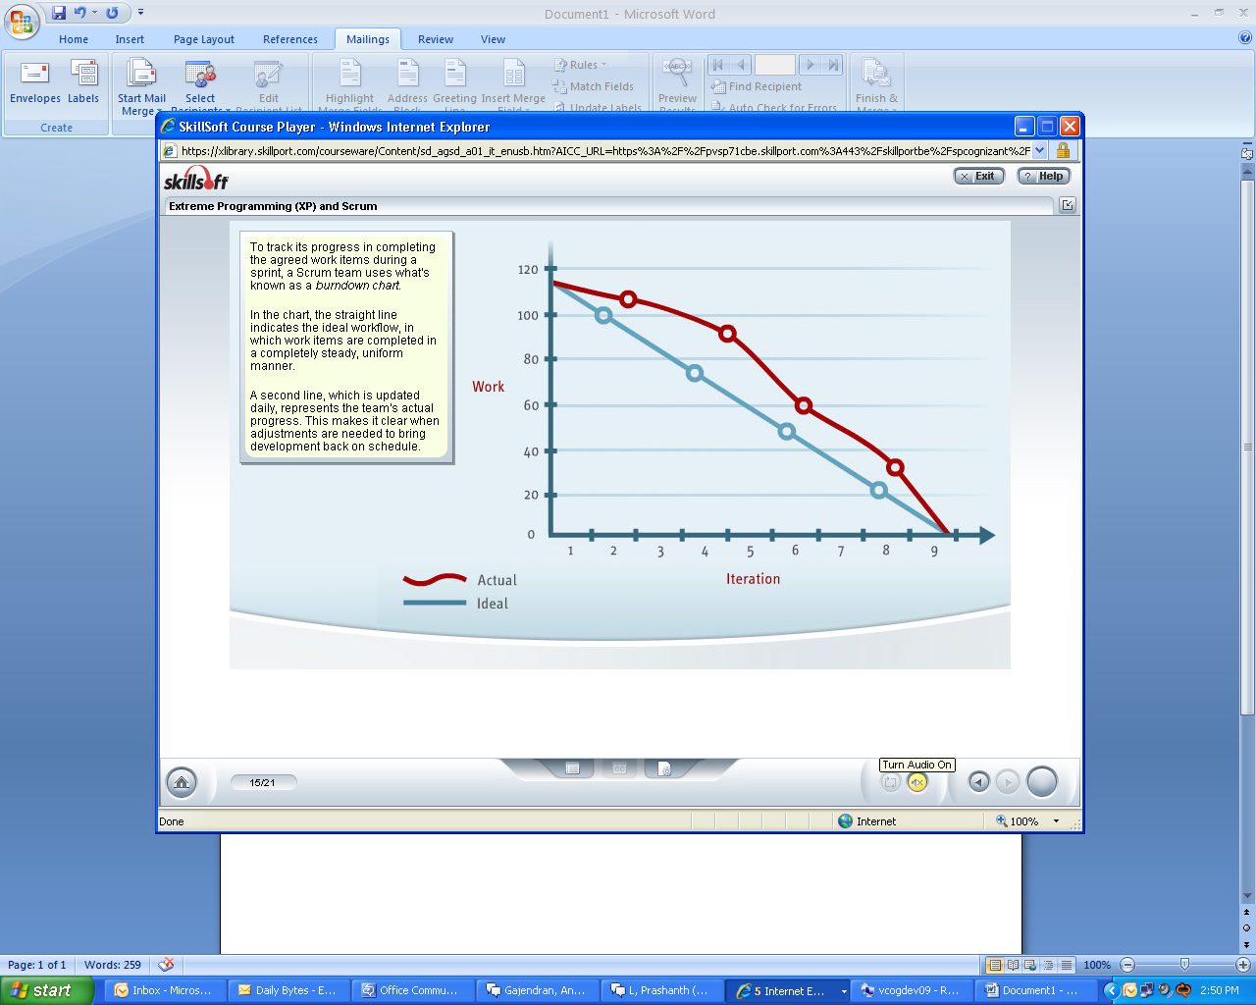

**What is an Agile retrospective?**

The Agile retrospective can be thought of as a "lessons learned" meeting.

An Agile retrospective is a meeting that's held at the end of iteration in [Agile software development](https://www.techtarget.com/searchsoftwarequality/definition/agile-software-development). During the retrospective, the team reflects on what happened in the iteration and identifies actions for improvement going forward.

Each member of the team members answers the following questions:

* What worked well for us?
* What did not work well for us?
* What actions can we take to improve our process going forward?

Agile backlog grooming involves: Deciding which user stories to pursue in the next sprint.